

addb test paper

ST10053561



October 10, 2023

varisty college

Table of Contents

Figure 1 : Question 1 3

Figure 2 : Question 2 3

Figure 3 : Question 3 Half Picture with the output and query 4

Figure 4 : Question 3.2 full picture of output and query. 5

Figure 5 : Question 4 5

Figure 6 : Question 5 6

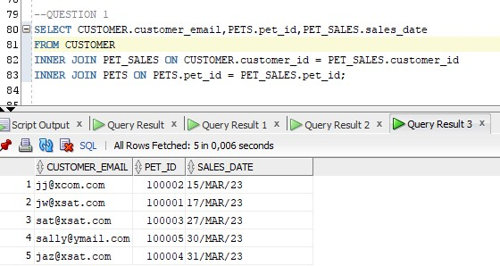

Figure : Question 1

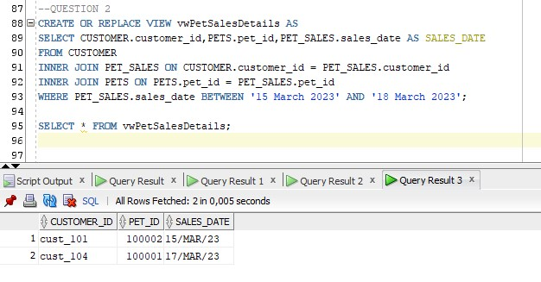

Figure : Question 2

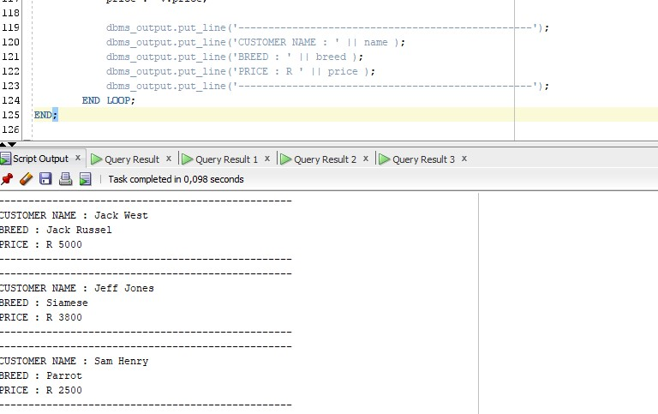

Figure : Question 3 Half Picture with the output and query

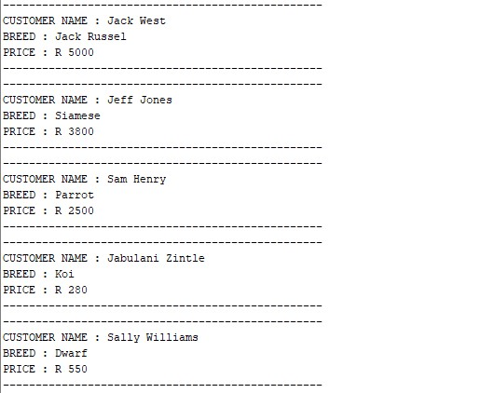

Figure : Question 3.2 full picture of output and query.

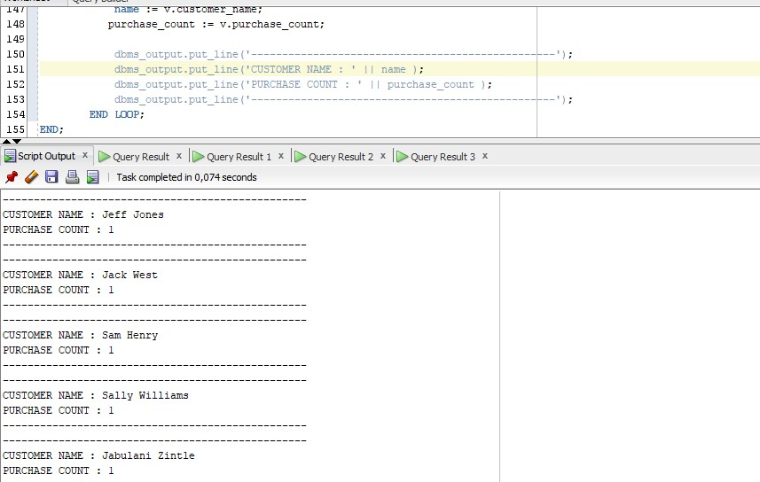

Figure : Question 4

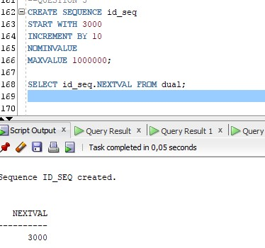

Figure : Question 5